The Birds of Opulence by Crystal Wilkinson  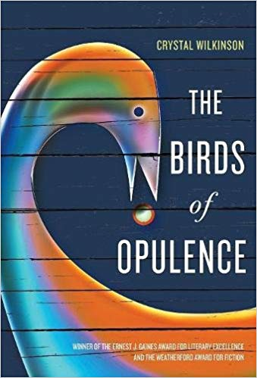
From the opening paragraph of Crystal Wilkinson’s lyrical and richly written The Birds of Opulence, we know this grand and uncommon book will be an extraordinary story about the lives of women and the gentle men who love them, both a “country” story and universal story that will change one’s life for the reading: “Imagine a tree, a bird in the tree, the hills, the creek, a possum, the dog chasing the possum. Imagine yourself a woman who gathers stories in her apron.” Before you read The Birds of Opulence, click on the Appalachian Heritage Writer-in-Residence (AHWIR) website and read about Wilkinson, explore some of the links on the Teaching Tools and Resources page, and prepare for a read that will transcend the usual linear narrative experience. Take this book in hand and in mind, and read it creatively. Notice the chapter titles and be aware of the transitions between past and present (the author’s use of past and present tense is a clue)—as Wilkinson takes us in and around the minds of these extraordinary “birds” of Opulence. This is a story about the Good, Brown, and Clark families, as well as the black township of Opulence—good country people who provide the roots for each of us, whether we are Black, Appalachian, or any other group of Americans; for all of us have hailed from “country” to some degree, and, try as we may to escape from those roots, they will find us.
As you read, be alert for all the different meanings of “birds”—from casual comments used to characterize flighty women or women who live their lives a bit off the beaten track, to something magical, special, and lovely, to harbingers of death, to the colorful, the different, and the beautiful. Mark in your book each time you find a different nuance for this rich symbol. Notice as well the organic structure of this book where symbols and images are repeated (for example the chased possum at the beginning and end of the chapters narrating Yolanda’s birth); and be aware of the Stream of consciousness (narrative mode), where past time and linear time collide. How was Opulence established, and what connection does it have with Eatonville, Florida which figures in the work of Zora Neale Hurston; how is Opulence both like so many other small country towns and different? Notice how Wilkinson develops the chapters “Dinner on the Grounds” (103) and the “Home Place” (111). What is the great African American Diaspora (from the Jim Crow South), how does it parallel the Appalachian Diaspora, and what does it say about “being country”? Who are the “Kitchen Ghosts” at the end of the book? Describe the power and presence in the family and community of Minnie Mae, Tookie, and Lucy. How do these women read “signs” from the natural world, and how do they function in the daily living of their lives? How do Kee Kee and Joe Brown fit into this world of women? How is the final chapter about the Home Place wonderfully ironic, as Joe Brown visits to plant roses in memory of Lucy and is run off the land by the new owners?
In some ways, this book is a coming-of-age story, or Bildungsroman, for two young black girls, Yolanda Brown and Mona Clark. How so, and what do they have to be wary of when they become teens, and why do so many of the women say their sons are easier than their girls to raise? What part does the episode play in their story where the two girls stray onto the Simpson land and have an encounter with Obie Simpson? What does Mona learn about men from this encounter? What do Obie, Marshall Ross, Bruce Harrison, and Kee Kee have in common, and how are they different? This is also a book that deals with a topic rarely written about in Appalachian or Black literature—the mental health struggles of characters. Who struggles in this regard? How does the community react to mental illness? What separates characters like Joe Brown from others dealing with this problem? This is also a story about family secrets and the dynamics and complexity of family life. What haunts Tookie from the time she is a 13-year-old until the end of her life? What is a sign immediately preceding Tookie’s death? How does Tookie’s experience connect with Mona and Yolanda’s? Explain how this book is ultimately an extraordinary story about what it means being human.

